9715 Stewartown Rd Sign Plan
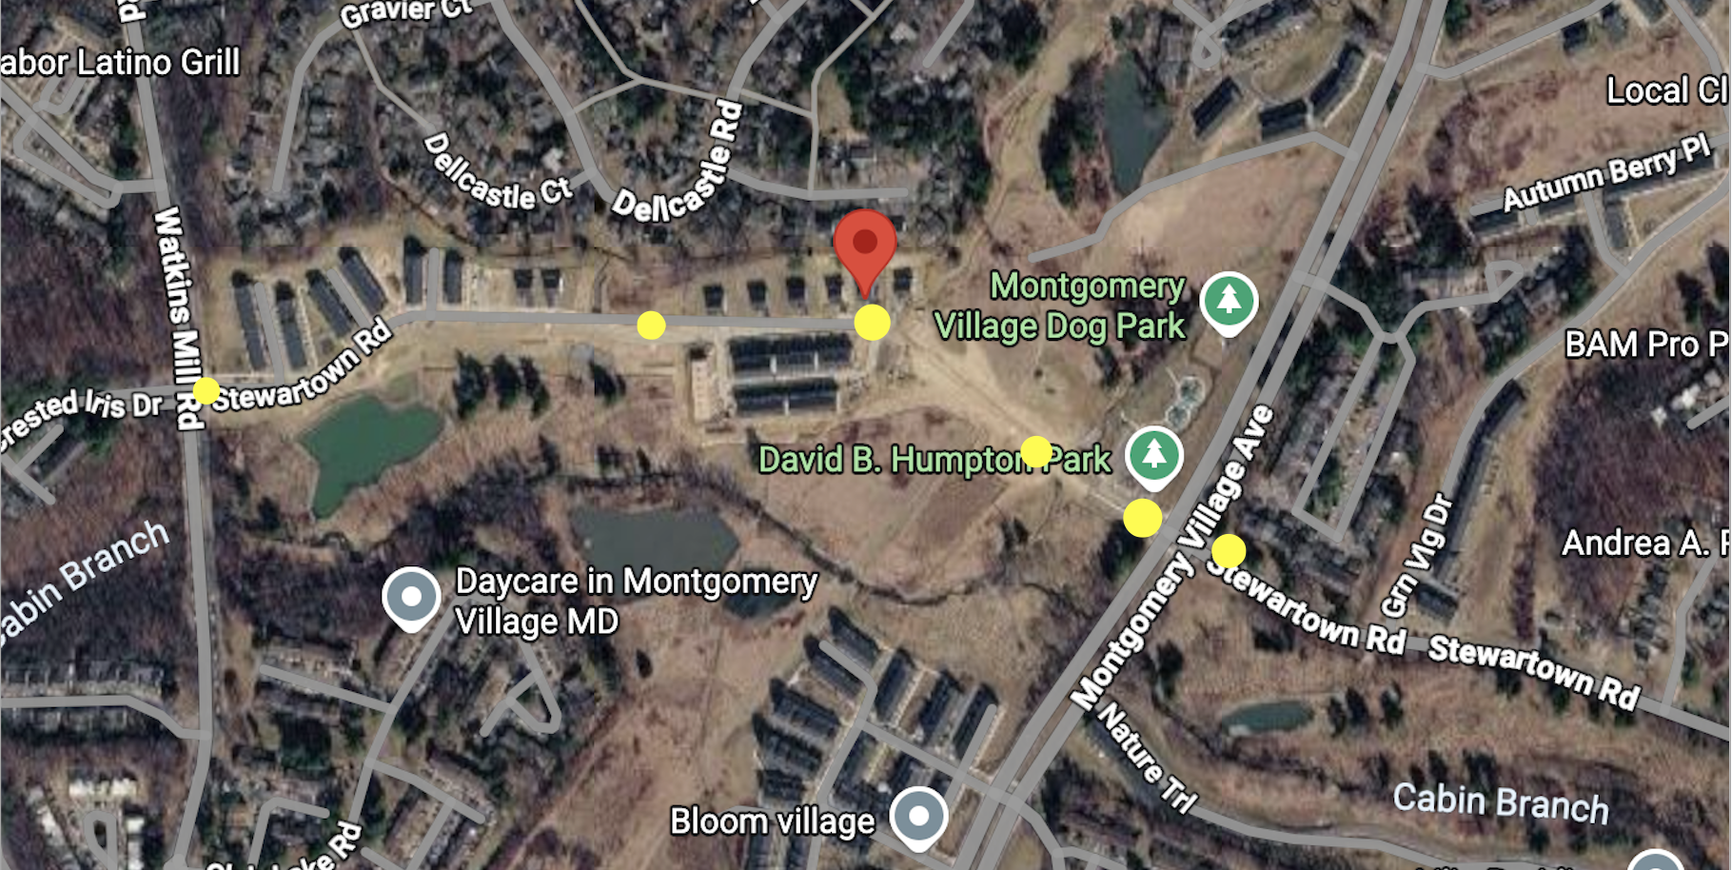

The road from Montgomery Village to Stewartown doesn’t show up on maps yet, but it is open.
- Montgomery Village and Stewartown (there is a park entrance there)
- Stewartown where there are 2 barriers you drive between
- Front of house
- Middle of Stewartown Rd
- Stewartown and Watkins Mill Rd

